Aperius Consulting

Windows 10.5.6

Summary:

- Every week, we are given 21 ‘windows’ of opportunity.
- It’s important to use those windows ‘consciously’.
- Lifetime is finite. Don’t squander it.

Windows 10.5.6 – an Operating System for Life
Roger Alderson, Aperius Consulting

I recently stumbled on Windows 10.5.6. Not an operating system for my computer but rather a philosophical operating system for my life.
Every week, there are 21 ‘windows of opportunity’
- The ‘10’ refers to the working windows (morning and afternoon) that are available each Monday through Friday.
- The ‘5’ refers to the personal windows that are available each evening of the working week.
- Finally, the ‘6’ refers to the additional personal windows available over the weekend (Saturday morning through Sunday evening).

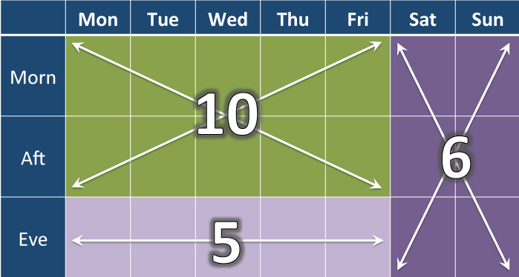
It’s a concept within which to think about how you’re investing your time, and it’s a useful framework. 21 ‘windows’ a week with 10 (typically) focused on work and 11 for personal activities. To understand a little more, here is some basic arithmetic.

Assuming a working life of 47 years (18 through 65), with four weeks of vacation a year and another week a year for ‘other’ things (training, illness, travel). This means that over your career you’ll have:

- 22,090 windows (43%) available for work.
- 24,299 windows (47%) available for personal activities.
- 3,948 windows (8%) available for vacations.
- 987 windows (2%) available for ‘other’ activities.

At first glance this seems pretty good, especially in terms of work/life balance. There are a lot of windows within a working lifetime. Better still, more than half of them are personal. The average twenty-year old sees this long bright future stretching out ahead of them with a seemingly limitless reservoir to tap into. At twenty, that’s true. But at thirty, the windows of opportunity are declining rapidly.
Although it appears that there are lots of windows of opportunity, they are constantly eroding.

- By age 35, you’ve used up 36% of your working lifetime.
- By 50, you’ve used up 69%.
- By 60, you’ve used up 89%.

Time is not an infinite resource. So using a ‘window’ to watch a bad movie, or play a game on your phone, or sit in a pointless business meeting is really a waste of time. It becomes especially apparent if you start adding these wasted windows up. For example, imagine that you attend just one worthless (3hr) meeting a month. That will soak up 564 windows over a career, 2.5%.

Summary

Bottom line - life is VERY finite. You (probably) only get one try, so make it count! Think about the 10.5.6 windows that are open to you every week, and use them wisely – they’re precious.

CONTACT
M: +44 (0)7966-126882
E: roger@aperius.com
T: @RTAlderson
www.aperius.com

Copyright and Restrictions

Chances are, I won’t mind if you re-purpose this material or use it in advertising, press releases or promotional materials (including translated/localised content). However, please get in touch and let me know what you’re planning to use it for.

Copyright 2016 Roger Alderson and Aperius Consulting.
Reproduction forbidden unless authorized.
All rights reserved.

